**Index.html**  
  
image1: jumbotron

  
(Example) <https://bootstrapmade.com/demo/Mentor/>

Header: Sound Of Music  
p: Being one of Asia’s Leading Music Retailer, Tunes’ journey began in 1998 when seeing that music could shape both soul and society, we set out to establish a legacy of our own.  
*find out more button*  
  
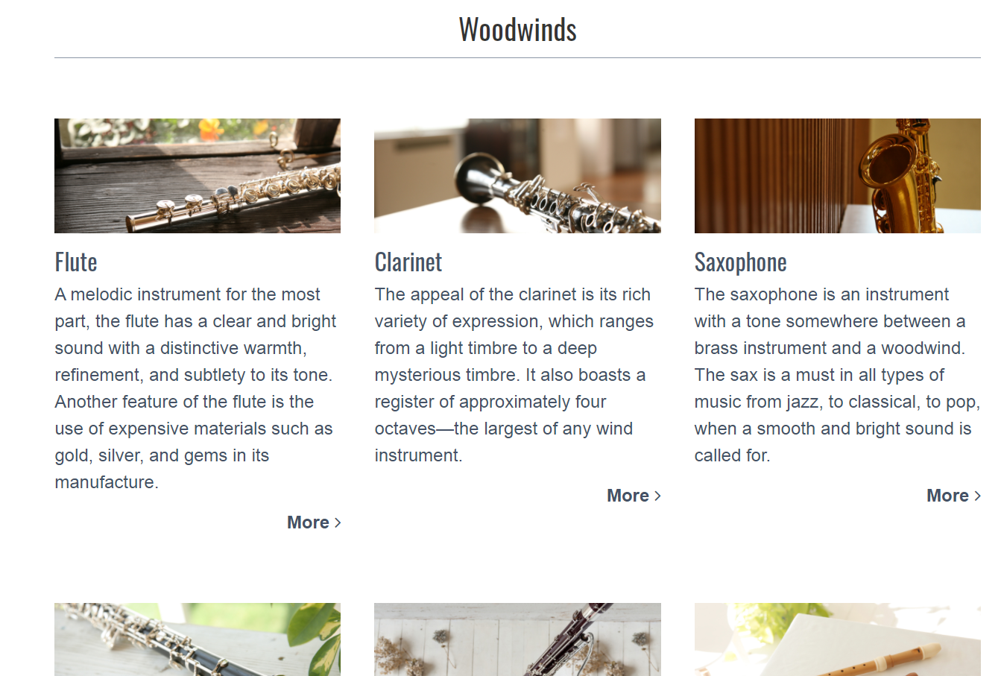  
(Example)  
<https://www.yamaha.com/en/musical_instrument_guide/>   
  
Musical Instrument Guide

Para: There are three basic categories of musical instruments:  
---------Divider ------

|  |  |  |
| --- | --- | --- |
| (Image MIG1) **Percuss­­ion**  A percussion instrument is a musical instrument that is sounded by being struck or scraped by a beater including attached or enclosed beaters or rattles struck, scraped or rubbed by hand or struck against another similar instrument.  (button: Read More) link to percussion.html | (Image MIG2) **Woodwind**  Woodwind instruments are a family of musical instruments within the more general category of wind instruments. Common examples include flute, clarinet, oboe, bassoon, and saxophone.  (button: Read More)  link to woodwind.html | (Image MIG3) **Strings**  A string is the [vibrating element](https://en.wikipedia.org/wiki/Vibrating_string) that produces [sound](https://en.wikipedia.org/wiki/Sound) in [string instruments](https://en.wikipedia.org/wiki/String_instrument) such as the [guitar](https://en.wikipedia.org/wiki/Guitar), [harp](https://en.wikipedia.org/wiki/Harp), [piano](https://en.wikipedia.org/wiki/Piano) ([piano wire](https://en.wikipedia.org/wiki/Piano_wire)), and members of the [violin family](https://en.wikipedia.org/wiki/Violin_family).  (button: Read More)  link to strings.html |

**Aboutus.html**Image Slideshow (aboutus1 – aboutus5 images)

**Percussion.html**

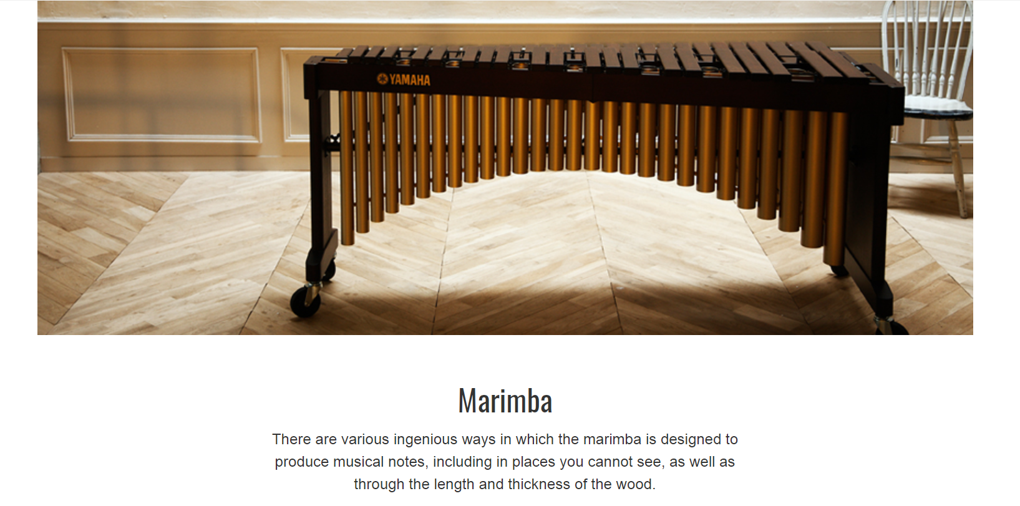(Example)

(Image marimba)Marimba  
p: The marimba is a percussion instrument consisting of a set of wooden bars struck with yarn or rubber mallets to produce musical tones.

(Image timpani)  
Timpani  
p: A type of drum categorised as a hemispherical drum, they consist of a membrane called a head stretched over a large bowl traditionally made of copper. The timpani is an indispensable part of any orchestra, with

**Woodwinds.html**

(Example)

(Image flute)Flute  
p: A flute is an aerophone or reedless wind instrument that produces its sound from the flow of air across an opening. It has a clear and bright sound with a distinctive warmth, refinement, and subtlety to its tone.

(Image clarinet)  
Clarinet  
p: Clarinet has a single-reed mouthpiece, a straight, cylindrical tube with an almost cylindrical bore, and a flared bell. It also boasts a register of approximately four octaves-the largest of any wind instrument.

(Image saxaphone)  
Saxaphone  
p: The saxophone is usually made of brass and played with a single-reed mouthpiece. It is an instrument with a tone somewhere between a brass instrument and a woodwind. The sax is a must in all types of music from jazz, to classical, to pop, when a smooth and bright sound is called for.

(Image Oboes)  
Oboe  
p: The oboe is a type of double reed woodwind instrument and the most common **oboe** plays in the treble or soprano range. Its name comes from the French for "high-pitched wood," are excellent for solo performances with many notes in high ranges. The oboe is extremely difficult to play.

(Image Bassoon)  
Bassoon  
p: The bassoon is a woodwind instrument in the double reed family that plays music written in the bass and tenor clefs, and occasionally the treble. The long, wide wooden pipe of the bassoon contains much wisdom.

(Image recorder)  
Recorder  
p: Recorder known as internal duct flutes—flutes with a whistle mouthpiece, also known as fipple flutes. It is also familiar to most as the instrument used today in school lessons. However, its history extends to ancient times, and modern day performers are active in a wide range of settings.

**Strings.html**

(Example)

(Image classicalguitar)Classical Guitar  
p: An acoustic wooden string instrument with strings made of gut or nylon. The classical guitar can play a wide range of types of music-from classical music to bossa nova and jazz.  
Dubbed a mini-orchestra, the classical guitar covers an impressive range of timbres.

(Image Acousticguitar)  
Acoustic Guitar  
p: Acoustic Guitar’s strings vibrate a sound board on a resonant body to project a sound wave through the air. The timbre of a guitar is determined by its body. Most people have never looked inside a guitar and may not realize it, but guitars are actually very cleverly designed.

(Image electricguitar)  
Electric Guitar  
p: An electric guitar is a guitar that requires external amplification in order to be heard at typical performance volumes, unlike a standard acoustic guitar. Even though electricity is used to amplify the volume, the body and neck are merely pieces of wood. These instruments come in unique shapes and colors.

(Image Violin)  
Violin  
p: The violin, sometimes known as a fiddle, is a wooden chordophone in the violin family. Most violins have a hollow wooden body. It is the smallest and thus highest-pitched instrument in the family in regular use. Whether performing an elegant solo or being the heart of the orchestra, the violin is a "star" in the music world.

its heavy bass sound that resonates deep in your abdomen.

(Image drum)  
Drum  
p: The drum is a member of the percussion group of musical instruments. As the "keeper of the rhythm," the drum provides the foundation for the overall sound of music.Because a drum only has to be hit to make a sound, it is also one of the simplest of the instruments.